

## SHRI GURU GOBIND SINGHJI

**INSTITUTE OF ENGINEERING & TECHNOLOGY**

## VISHNUPURI , NANDED – 431606 (MS) ACADEMIC YEAR

( 2023-24 )

### CERTIFICATE

This is to certify that the project/research work entitled “**FINANCE MANAGEMENT SYSTEM**” being submitted by Mr**. Parth Katke, Keshav Khekade , Karan Chirde** to Shri Guru Gobind Singhji Institute of Engineering & Technology, Nanded for the award of the degree B.Tech. in Computer Science & Engineering is a record of bonafide work carried out by them under my supervision and guidance. The matter contained in this dissertation has not been submitted to any other University or institute for the reward of any degree or diploma.

|  |  |  |
| --- | --- | --- |
| Name of Guide  **Mrs. Misha Nihalani** | Name of HOD Head  Department of CSE  **Dr. Suwarna Bansode** | Name of Director Director  SGGSIE&T, Nanded  **Dr. M. Kokare sir** |

# “DATABASE MANAGEMENT SYSTEM ”

Submitted for the degree of

## B. Tech

In

## COMPUTER SCIENCE & ENGINEERING

Under the Guidance of

**Ms. MISHA NIHALANI MA’AM**

.

## ACKNOWLEDGEMENT

For all the efforts behind the project work, we first & foremost would like to express our sincere

appreciation to respected Misha Nihalani Mam for their extended help & suggestions at every stage

of this project.

It is with a great sense of gratitude that we acknowledge the support, time to time suggestions are

highly indebted to our guide.

Finally, we pay our sincere thanks to all those who indirectly and directly helped us towards the

successful completion of this project report.

**INDEX**

**Abstract**

**1.Introduction**

**1.1** Bakground and Context

**1.2** Objectives of the Finance Management System:

**2.Literature survey**

**3.Diagrams**

**3.1** ER Diagram

**3.2** System diagram

**4.System Development & Implementation**

**5. Screenshots**

**6.Conclusion**

**6.1** Future Scope

**6.2** Benefits

**7. References**

# ABSTRACT

* In the dynamic landscape of entrepreneurial endeavors, effective financial management is the linchpin of success for startups. This project introduces an advanced accounting solution tailored specifically for startups, aiming to revolutionize financial efficiency through the integration of a robust Database Management System (DBMS) with a focus on technologies such as MySQL.
* This project aims to revolutionize financial management for startups by integrating a robust Database Management System (DBMS) with technologies like MySQL. The project streamlines financial processes, ensuring accuracy and efficiency in computations. It also automatically balances the balance sheet, providing a comprehensive overview of assets and liabilities. The integration of cutting-edge technologies, particularly MySQL, enhances computational power and adaptability to startups' evolving needs, empowering them with a user-friendly, efficient, and intelligent platform for managing finances.
* Beyond basic bookkeeping, this project goes a step further by automatically balancing the balance sheet. This functionality ensures that financial records are not only accurate but also in compliance with accounting principles. Startups can benefit from a comprehensive and organized overview of their assets and liabilities, presented at a glance. This instant insight facilitates strategic decision-making and allows entrepreneurs to focus on critical aspects of business growth.

**CHAPTER 1 INTRODUCTION**

Effective finance management is indispensable for individuals and organizations alike, serving

as a strategic compass for achieving financial goals and maintaining stability. It involves

prudent resource allocation, meticulous budgeting, and adept risk management, ensuring

optimal cash flow and fostering sustainable growth. Finance management plays a pivotal role

in debt management, investment decisions, compliance with regulations, and governance standards. For individuals, it facilitates personal financial planning, while in a business context,

it contributes to sustainability by optimizing costs, managing working capital, and ensuring profitability. Beyond these immediate benefits, finance management empowers

decision-making through informed assessments and strategic choices. Whether navigating personal milestones or steering organizational success, sound financial management practices

are integral for resilience, long-term growth, and the realization of financial objectives.

* 1. Background and Context

Effective asset and liability management stands as a linchpin for financial success and strategic acumen, applicable not only to startups but also to general businesses and individuals. Across the spectrum of

assets, the identification and valuation of resources, ranging from tangible assets like cash and inventory to intangibles such as intellectual property, form the bedrock. For all entities, whether startup, business, or individual, optimizing working capital becomes essential—striking a balance in managing accounts

receivable, payable, and inventory to ensure seamless day-to-day operations. Crafting a sagacious

investment strategy and balancing equity and debt are universal principles that transcend organizational

size.

On the liabilities front, prudent debt management is a shared imperative, emphasizing the delicate

equilibrium required to avoid undue financial strain. Whether in business or personal finance, diligent

attention to accounts payable remains paramount, involving negotiation for favorable terms with suppliers

and timely settlements. Contingent liabilities, such as legal claims, demand vigilance across the board, necessitating the development of strategies to navigate unforeseen financial obligations. Interest rate risk

and equity management, crucial for all entities, underscore the need for continuous monitoring and

adjustment to mitigate volatility and foster sustainable growth.

In harmonizing these principles, an integrated approach proves essential for businesses and individuals

alike. Aligning asset and liability management seamlessly with overarching strategy ensures a robust

financial foundation. Continuous monitoring and scenario analysis serve as universal tools, empowering

entities to adapt strategies in response to ever-evolving market conditions. Whether for startups, general businesses, or individuals, the artful orchestration of assets and liabilities emerges not only as a means to

fortify financial resilience but as a pathway toward a future where stability and informed decision-making prevail.

* 1. Objectives

An accounting project aimed at calculating and recording assets and liabilities should be driven by clear objectives to ensure financial accuracy, compliance, and strategic decision-making. Here are key objectives

for such a project:

1.2.1 Financial Accuracy:

- Objective: Ensure precise calculation and recording of assets and liabilities.

- Rationale: Accurate financial data forms the foundation for reliable financial statements and informed decision-making.

1.2.2 Compliance with Standards:

- Objective: Adhere to accounting standards and regulations.

- Rationale: Compliance ensures the reliability and consistency of financial information, promoting trust among stakeholders.

1.2.3. Transparent Financial Reporting:

- Objective: Facilitate transparent communication of financial positions.

- Rationale: Transparency fosters trust among stakeholders and aids in making well-informed financial decisions.

1.2.4. Effective Resource Allocation:

- Objective: Provide insights for optimal resource allocation.

- Rationale: Understanding assets and liabilities aids in strategic resource management and allocation for sustainable growth.

1.2.5. Risk Assessment and Management:

- Objective: Identify and manage financial risks associated with assets and liabilities.

- Rationale: Proactive risk assessment enables the development of strategies to mitigate potential financial challenges.

1.2.6. Strategic Decision Support:

- Objective: Equip decision-makers with reliable financial information.

- Rationale: Accurate data empowers leaders to make informed decisions that align with organizational

goals and objectives.

1.2.7. Efficient Audit Trail:

- Objective: Establish a clear and auditable record of financial transactions.

- Rationale: An efficient audit trail ensures accountability, aiding internal and external audits.

1.2.8. Cash Flow Management:

- Objective: Facilitate effective cash flow management.

- Rationale: Understanding liabilities and assets helps in maintaining liquidity and ensuring smooth

day-to-day operations.

1.2.9. Long-Term Financial Planning:

- Objective: Support long-term financial planning.

- Rationale: A comprehensive view of assets and liabilities enables organizations to plan for future

investments and expansion.

1.2.10. Continuous Improvement:

- Objective: Encourage a culture of continuous improvement in financial processes.

- Rationale: Regularly assess and enhance accounting practices to adapt to changing business

environments.

By aligning the accounting project with these objectives, organizations can build a robust financial

management system that not only meets immediate needs but also sets the stage for sustained financial

health and growth.

**CHAPTER NO. 2 LITERATURE REVIEW**

Developing an accounting project centered on the meticulous calculation and recording of assets and liabilities is imperative for organizations seeking financial precision. The primary objective revolves

around achieving the highest level of accuracy through the utilization of advanced technologies,

specifically Python for overall project management, scikit-learn for enhanced data analysis capabilities,

and Tkinter for a seamless user interface. This technological integration ensures not only the precise quantification of financial elements but also meticulous recording practices, forming the foundation for generating reliable financial statements. The incorporation of Python, scikit-learn, and Tkinter enables a sophisticated approach to data-driven decision-making, instilling confidence in stakeholders and

contributing to strategic financial management.

In addition to technological prowess, a secondary focus of the project involves the prioritization of compliance with established accounting standards and regulations. The implementation of Python and MySQL as the chosen database management system ensures a robust framework for adherence to these standards. This strategic use of technology guarantees the consistency and reliability of financial

information, positioning the organization within legal frameworks and effectively mitigating the risks associated with legal and regulatory repercussions. The project's commitment to compliance serves as a testament to its dedication to maintaining financial integrity and accountability.

Lastly, the accounting project, rooted in Python, scikit-learn, Tkinter, and MySQL technologies, is

designed to foster a culture of continuous improvement. Objectives are structured around the refinement

of financial processes, incorporating regular assessments and enhancements. This approach enables the organization to proactively adapt to dynamic business environments, staying ahead in the ever-evolving landscape of financial management best practices. By intertwining technology and strategic objectives,

the accounting project not only achieves immediate goals of precision and compliance but also lays a

robust foundation for sustained financial resilience and informed strategic decision-making.ortunities

and challenges of this innovative technology.

**CHAPTER NO. 3**

**Diagrams**

**3.1 ER-Diagram**

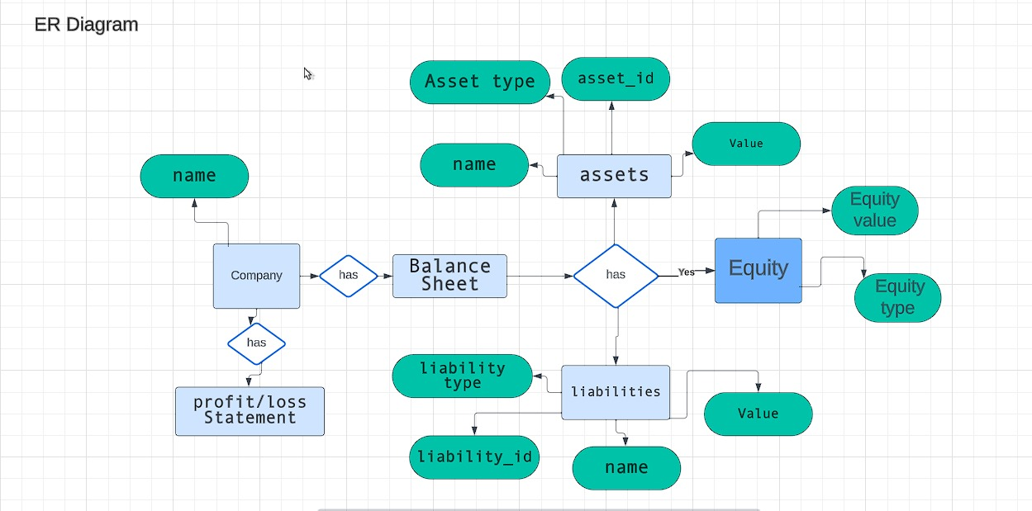

**3.2 System Diagram**

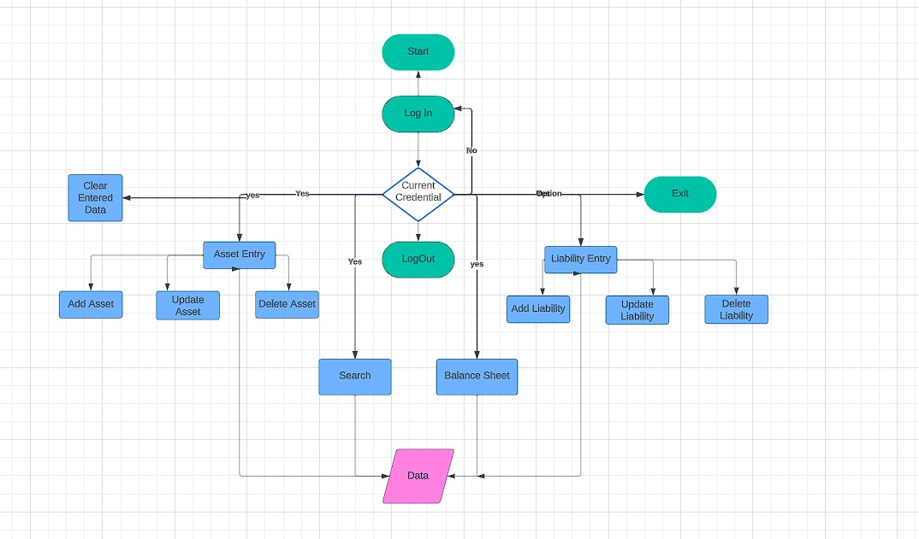

**CHAPTER NO.4**

**System Development & Implementation**

System development and implementation is a critical process that involves creating, testing, and

deploying an information system to meet specific business or organizational needs. This multifaceted

process encompasses various stages, each playing a crucial role in the successful delivery of a

functional and effective system. Below is an overview of the key steps in system development and implementation:

**4.1 System Development**

### 4.1.1 Requirements Gathering and Analysis

The initial phase involves understanding the requirements of the Finance Management System. Key functionalities include budgeting, expense tracking, financial reporting, and user authentication. Interviews with stakeholders and thorough analysis of existing financial processes were conducted to derive comprehensive requirements.

### 4.1.2 System Design

Database Design:

Utilizing MySQL as the relational database, the system's database schema was designed to store financial data efficiently. Tables for transactions, budgets, users, and other relevant entities were created. Relationships were established to ensure data integrity.

User Interface Design:

The graphical user interface was designed using the Tkinter library in Python. The design focused on user-friendly navigation, with screens for entering transactions, viewing financial reports, and managing budgets. The interface was developed with a clean and intuitive layout.

## 4.2. System Implementation

### 4.2.1 Technology Stack:

The Finance Management System was implemented using the following technologies: Python: Used as the primary programming language for system logic and backend development.

MySQL: Employed as the relational database management system for data storage.

Tkinter: Chosen for developing the user interface due to its simplicity and integration with Python.

### 4.2.2 Backend Development:

Database Connectivity:

Python's MySQL Connector was used to establish a connection between the application and the MySQL database. SQL queries were implemented to retrieve, insert, update, and delete data based on user actions.

Business Logic:

Python functions were developed to implement the core business logic of the Finance Management System. This includes algorithms for budget calculations, expense categorization, and financial reporting.

### 4.2.3 Frontend Development:

# Tkinter Widgets:

Tkinter widgets such as Entry, Label, Button, and Frame were utilized to create a responsive and interactive user interface. Event handlers were implemented to capture user inputs and trigger appropriate actions.

Styling and Layout

The Tkinter application was styled using the native theming options and layout managers. Consistent color schemes and fonts were applied for a professional and cohesive appearance.

### 4.2.4 Testing and Debugging:

Comprehensive testing was conducted to identify and rectify bugs or inconsistencies. Test cases were developed to validate functionalities such as transaction entry, budget updates, and report generation. Debugging tools were employed to address any issues that arose during testing.

### 4.2.5 Deployment:

The Finance Management System was deployed on a server, making it accessible to users. Necessary security measures, such as user authentication and encrypted connections, were implemented to safeguard sensitive financial data.

**CHAPTER NO. 5**

**Screenshots**

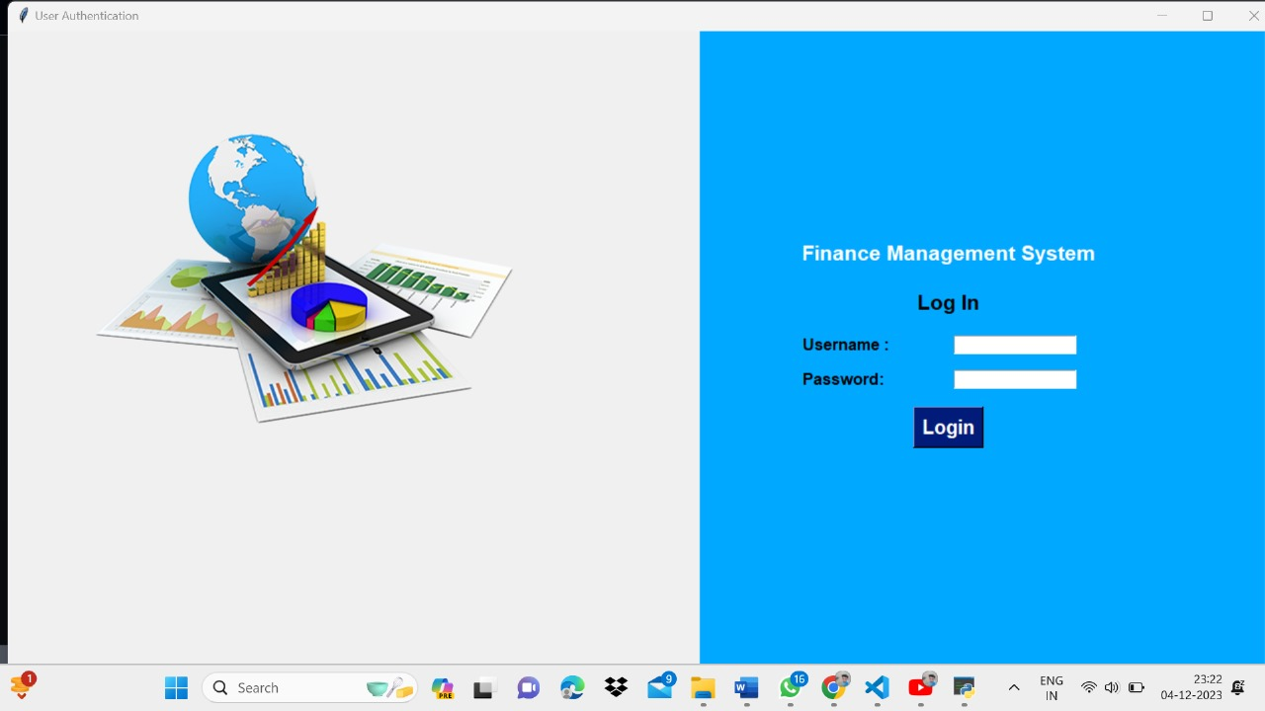

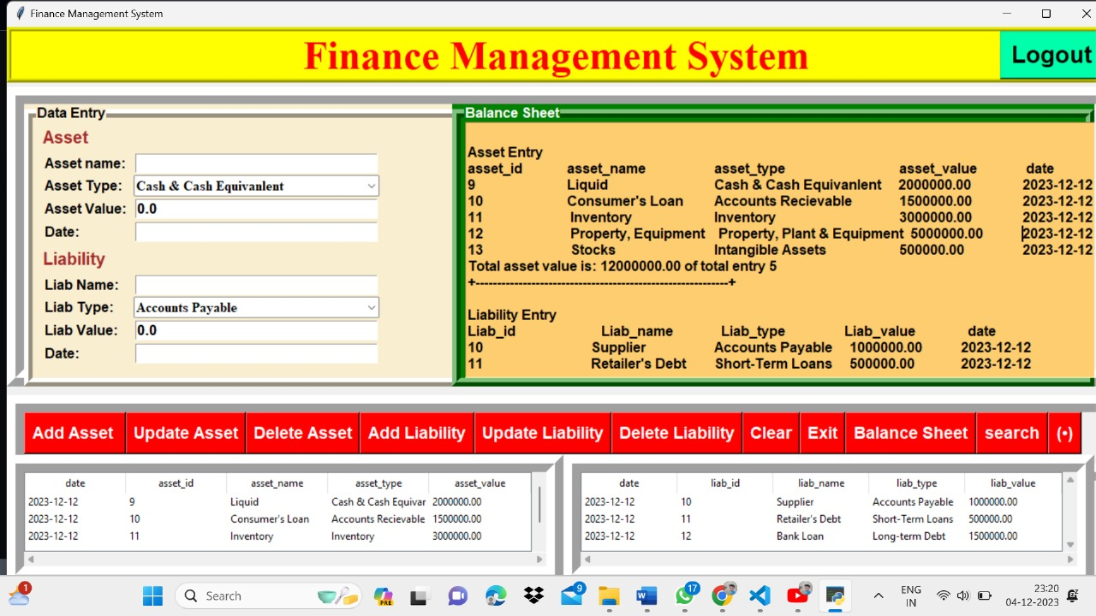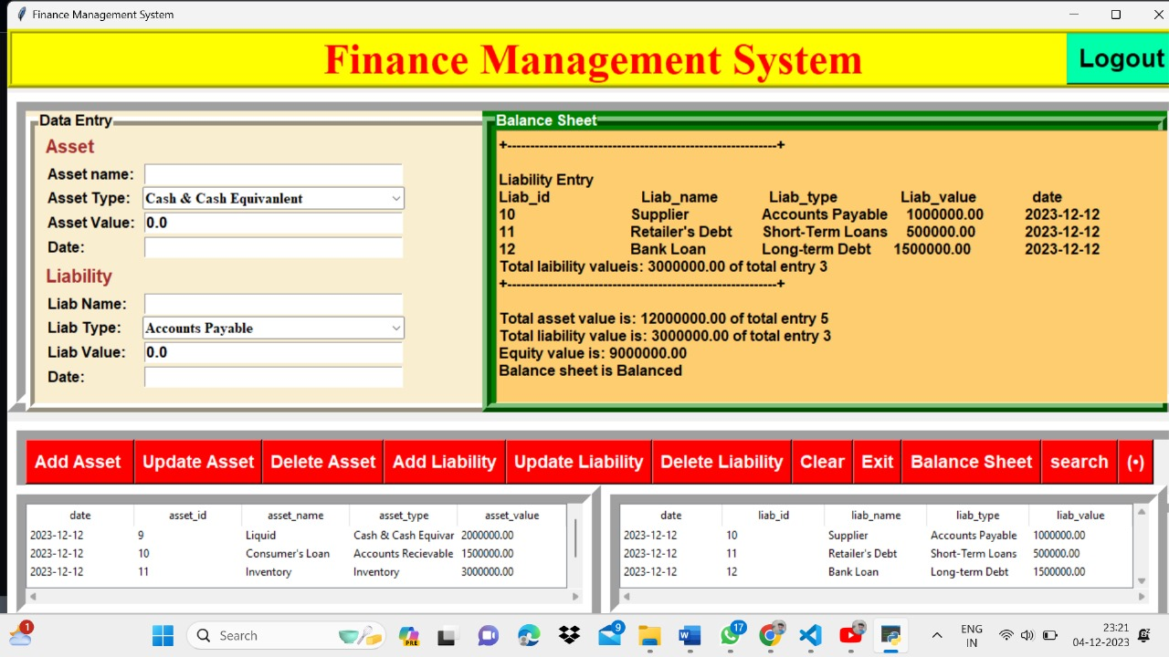

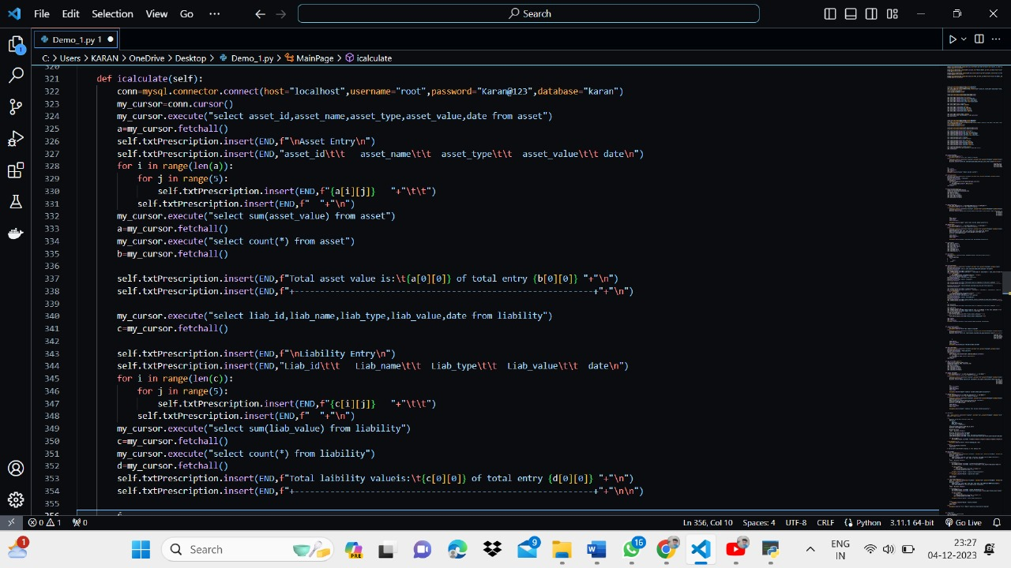

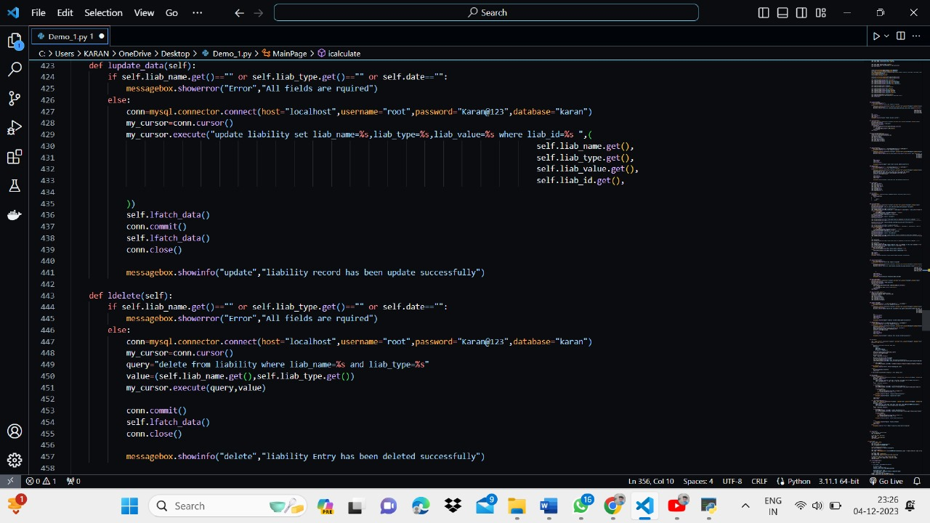

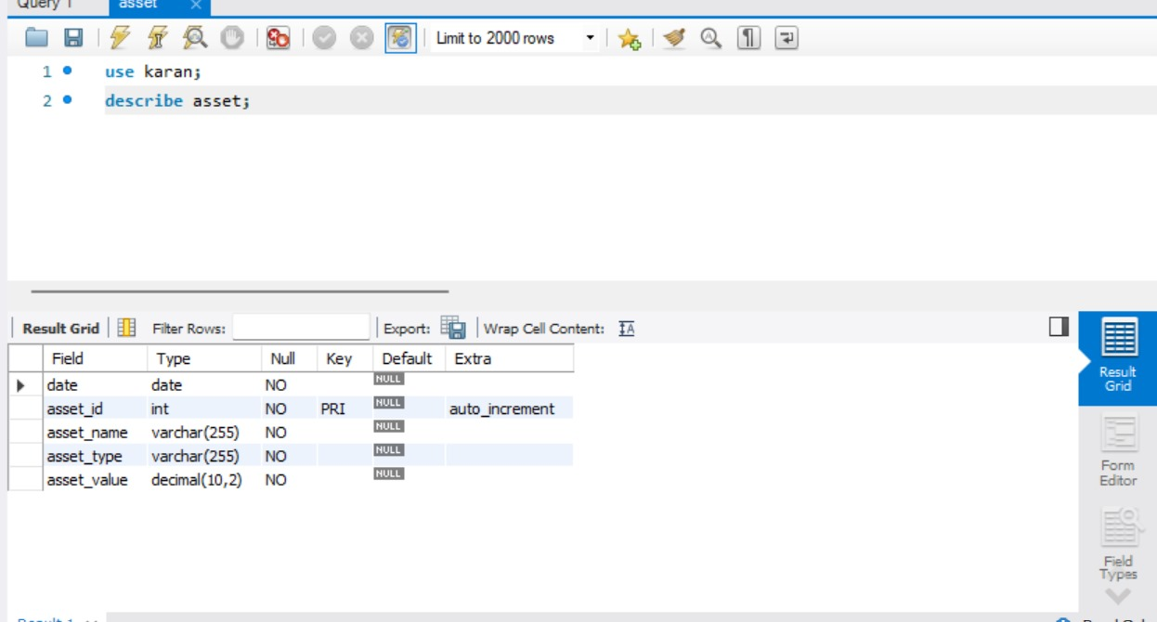

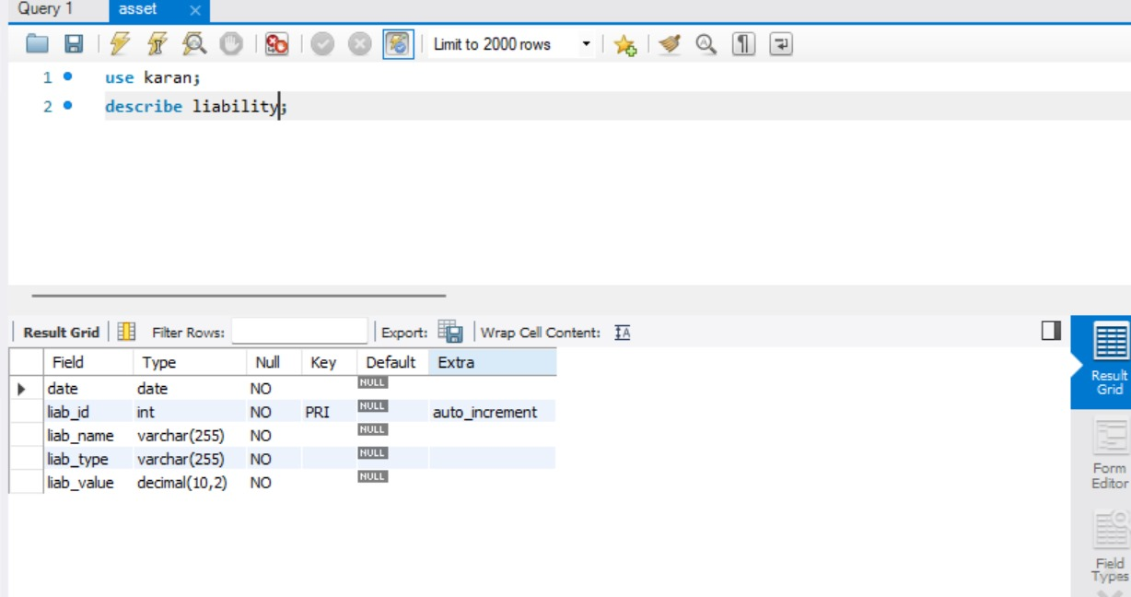

**CHAPTER NO. 6**

**Conclusion**

The Finance Management System, developed using Python, MySQL, and Tkinter, represents a

significant leap forward in enhancing financial control and management efficiency. The system

addresses the challenges faced by individuals and organizations in managing their finances,

particularly by replacing manual methods with a streamlined, automated approach. The implementation of

a robust database structure in MySQL ensures the secure storage and retrieval of financial data,

contributing to data integrity and reliability.

The user interface, built with Tkinter, offers a user-friendly experience, making financial management

accessible even to those with limited technical expertise. The system's features, including budgeting,

expense tracking, and financial reporting, empower users to make informed decisions and gain insights

into their financial health. The application's adherence to design principles, such as clean layouts and

intuitive navigation, enhances usability and overall user satisfaction.

The adoption of Python as the primary programming language contributes to the system's flexibility and

ease of maintenance. Python's versatility allows for efficient backend development, incorporating

complex business logic while maintaining readability and scalability. The utilization of Tkinter

widgets for frontend development ensures a consistent and visually appealing interface.

Throughout the development process, rigorous testing and debugging procedures were implemented,

resulting in a stable and reliable Finance Management System. The system underwent comprehensive

testing, covering various scenarios to identify and address potential issues. As a result, users can

confidently rely on the system for accurate financial tracking and reporting.

In conclusion, the Finance Management System is not merely a technological solution; it is a

transformative tool that empowers individuals and organizations to take control of their finances. By

leveraging modern technologies, the system provides a comprehensive and user-centric platform for

financial management, aligning with the evolving needs of users in an ever-changing financial

landscape. Continuous efforts will be directed towards maintaining and improving the system, ensuring

its long-term relevance and effectiveness in meeting the dynamic challenges of financial management.

## 6.1 Future Scope

The future scope for the Finance Management System includes a range of enhancements and

expansions that can further elevate its utility, user experience, and adaptability to evolving financial

landscapes. Here are detailed points outlining the future scope:

1. Integration of Machine Learning Algorithms:

- Explore the integration of machine learning algorithms to provide predictive analytics and

personalized financial insights.

- Implement algorithms that can analyze spending patterns, forecast future expenses, and offer tailored

financial advice.

2. Mobile Application Development:

- Develop a dedicated mobile application for the Finance Management System to provide users with

on-the-go access to their financial information.

- Optimize the user interface for mobile devices, ensuring a seamless and responsive experience.

3. Enhanced Security Features:

- Implement advanced security measures, such as biometric authentication and multi-factor

authentication, to fortify data protection.

- Explore blockchain technology to enhance the security and transparency of financial transactions.

4. Real-time Financial Data Updates:

- Integrate real-time data updates to provide users with instantaneous insights into their financial status.

- Implement automatic synchronization with bank accounts and financial institutions for

up-to-the-minute transaction data.

5. Expense Categorization using Natural Language Processing (NLP):

- Employ NLP techniques to automate the categorization of expenses based on natural language

descriptions.

- Enhance the system's ability to intelligently categorize and analyze diverse types of financial

transactions.

6. Integration with Financial APIs:

- Explore partnerships with financial institutions and third-party services to integrate additional financial

APIs.

- Enable users to link their accounts seamlessly, retrieve detailed transaction data, and access a broader

spectrum of financial services.

7. Advanced Reporting and Visualization:

- Implement advanced data visualization techniques to offer users interactive and customizable financial

reports.

- Integrate graphical representations, charts, and graphs for a more intuitive understanding of financial

trends.

8. Multi-Currency Support:

- Incorporate multi-currency support to accommodate users dealing with international transactions.

- Provide real-time currency conversion rates and accurate representation of financial data in multiple

currencies.

9. Expense Approval Workflows:

- Introduce workflow functionalities for expense approvals, especially in organizational settings.

- Allow designated approvers to review and authorize specific expenses, enhancing control over

corporate spending.

10. Enhanced User Collaboration Features:

- Introduce collaborative features, enabling families or teams to manage shared budgets and financial

goals.

- Implement real-time updates and notifications to facilitate seamless communication among users.

11. Continuous User Education and Support:

- Develop a knowledge base and interactive tutorials to educate users on financial management best

practices.

- Offer in-app support and chat functionalities to assist users with any queries or challenges they may

encounter.

12. Regulatory Compliance Updates:

- Regularly update the system to comply with evolving financial regulations and standards.

- Stay abreast of changes in tax laws, financial reporting requirements, and compliance frameworks

to ensure users remain in adherence.

13. Cloud Integration and Scalability:

- Explore cloud-based solutions for enhanced scalability and accessibility.

- Integrate with popular cloud platforms to ensure seamless data storage, backup, and recovery.

14. User Feedback Mechanism:

- Implement a robust feedback mechanism to gather user insights and suggestions.

- Use user feedback to continuously improve system features, identify potential issues, and enhance

overall user satisfaction.

15. Gamification Elements for Financial Goal Achievement:

- Introduce gamification elements to make financial management engaging and encourage users to

achieve their savings and investment goals.

- Reward users for meeting financial milestones and practicing sound financial habits.

### 6.2 Benefits

Implementing a Finance Management System offers a multitude of benefits for individuals, businesses, and organizations. Here are detailed points highlighting the advantages:

1. Accurate Financial Tracking:

- Enables precise monitoring of income, expenses, and overall financial transactions, providing a

real-time snapshot of financial health.

2. Budget Optimization:

- Facilitates the creation and management of budgets, allowing users to allocate resources effectively

and make informed spending decisions.

3. Time Efficiency:

- Automates manual financial processes, saving time spent on paperwork and data entry, and allowing

users to focus on strategic financial planning.

4. Data Centralization:

- Centralizes financial data in a single system, reducing data silos and ensuring consistency across

different financial activities.

5. Error Reduction:

- Minimizes human errors associated with manual calculations and data entry, promoting accuracy in

financial records and reports.

6. Financial Planning:

- Provides tools for long-term financial planning, helping users set and achieve financial goals, save

for major expenses, and plan for retirement.

7. Expense Analysis:

- Offers detailed insights into spending patterns, allowing users to analyze and categorize expenses for

better financial decision-making.

8. Improved Decision-Making:

- Empowers users with actionable insights and data-driven decision-making capabilities, enhancing

overall financial management strategies.

9. Forecasting and Prediction:

- Incorporates features for financial forecasting, helping users predict future income, expenses, and

trends, aiding in proactive financial planning.

10. Enhanced Security:

- Implements security measures to protect sensitive financial data, ensuring confidentiality and

compliance with data protection regulations.

11. Auditing and Compliance:

- Facilitates easy auditing by maintaining a comprehensive record of financial transactions, supporting compliance with regulatory and internal audit requirements.

12. Customization and Scalability:

- Allows customization of financial reports and dashboards to meet specific user needs.

- Scales to accommodate growing data volumes and evolving financial requirements.

13. Cost Reduction:

- Reduces costs associated with manual paperwork, printing, and physical storage of financial

documents by digitizing and automating processes.

14. Mobile Accessibility:

- Offers mobile accessibility, allowing users to manage their finances on-the-go and access real-time

financial information from any location.

15. Collaboration and Accessibility:

- Facilitates collaboration by allowing multiple users to access and contribute to financial data.

- Provides accessibility through cloud-based solutions, ensuring data availability and continuity.

16. Debt Management:

- Assists in managing and reducing debt by providing a comprehensive overview of outstanding

balances, interest rates, and repayment schedules.

17. Enhanced Reporting:

- Generates detailed and customizable financial reports, including balance sheets, income statements,

and cash flow statements, aiding in financial analysis.

18. Strategic Goal Alignment:

- Aligns financial activities with strategic goals, helping businesses and individuals work towards

long-term financial objectives.

19. Tax Planning:

- Assists in tax planning by organizing financial data, tracking deductible expenses, and generating

reports that simplify tax filings.

20. User Education:

- Educates users on financial best practices and money management through insights and tutorials,

promoting financial literacy.

**CHAPTER NO. 7**

**References**

Finance Management System References:

1. Python Documentation:

- Official Python Documentation: The official Python documentation provides in-depth

information about the Python programming language, including syntax, libraries, and best practices.

- [Python Documentation](https://docs.python.org/)

2. MySQL Documentation:

- MySQL Documentation: The official MySQL documentation offers comprehensive guides on MySQL database management system, covering topics from installation to advanced queries.

- [MySQL Documentation](https://dev.mysql.com/doc/)

3. Tkinter Documentation:

- Tkinter Documentation: Explore the official documentation for Tkinter, the Python library used

for creating graphical user interfaces, to gain insights into widgets, layouts, and event handling.

- [Tkinter Documentation](https://docs.python.org/3/library/tkinter.html)

4. GeeksforGeeks Tutorials:

- GeeksforGeeks Python Programming Language: GeeksforGeeks provides tutorials on Python programming language, offering practical examples and explanations for various concepts.

- [GeeksforGeeks Python Tutorials]

(<https://www.geeksforgeeks.org/python-programming->language/)

5. W3Schools Python Tutorial:

- W3Schools Python Tutorial: W3Schools offers a comprehensive Python tutorial with practical examples and exercises, suitable for learners at different levels.

- [W3Schools Python Tutorial](https://www.w3schools.com/python/)

6. Real Python:

- Real Python: Real Python provides tutorials, articles, and resources for Python developers,

covering a wide range of topics from beginner to advanced levels.

- [Real Python](https://realpython.com/)

7. MySQL Tutorial by TutorialsPoint:

- MySQL Tutorial by TutorialsPoint: TutorialsPoint offers a MySQL tutorial with detailed

explanations and examples covering various aspects of MySQL database management.

- [TutorialsPoint MySQL Tutorial](https://www.tutorialspoint.com/mysql/index.htm)

8. Tkinter by Effbot:

- Tkinter by Effbot: Effbot's Tkinter tutorial provides practical examples and explanations for

building graphical user interfaces using Tkinter in Python.

- [Effbot's Tkinter Tutorial](http://effbot.org/tkinterbook/)

9. Codecademy Python Course:

- Codecademy Python Course: Codecademy offers an interactive Python course that allows

hands-on learning, making it suitable for beginners.

- [Codecademy Python Course](https://www.codecademy.com/learn/learn-python)

10. GitHub Repositories:

- Explore open-source Python and Tkinter projects on GitHub for code examples and inspiration. GitHub repositories related to finance management systems may provide valuable insights.

- [GitHub](https://github.com/)